The Seated Trunk Rotation Test

Test Objective For Seated Trunk Rotation Test
The Seated Trunk Rotation Test is designed to identify how much rotational mobility is present in the thoraco-lumbar spine. Good separation between the upper and lower body is important to help generate speed and maintain a stable posture during the golf swing.
Many golfers lack true thoracic spine rotation. The lack of rotation may cause them to create excessive lumbar spine rotational forces or over use the shoulder joint to compensate for limited thoracic spine mobility.

How To Perform The Seated Trunk Rotation Test
Begin by asking the client to get into a seated position with knees and feet together, body in an upright and erect posture, and arms extended out in the “W” position supporting a bar across the shoulders. Use two clubs or shafts on the ground to make two 45 degree angles to measure the players rotation. Ask the client to rotate the thorax both to the right and to the left as far as possible. See if the client can rotate past the 45 degree range on both sides. Many golfers rotate their shoulder blades back and forth and it looks like they are making a good shoulder turn, but they actual lack true thoracic spine rotation. This test assesses their true thoracic rotation with their shoulder blades locked in order to get a real picture of their spinal mobility.

Correct Testing Form
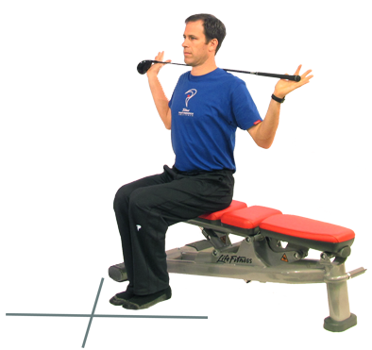

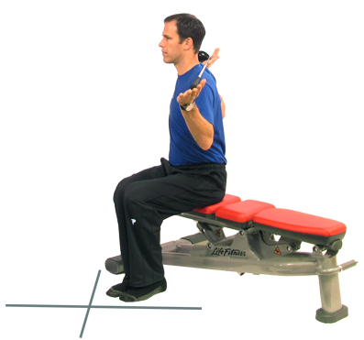

Incorrect Testing Form
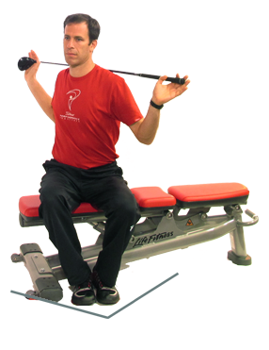

Knees Have Separated Indicating Movement In The Pelvis
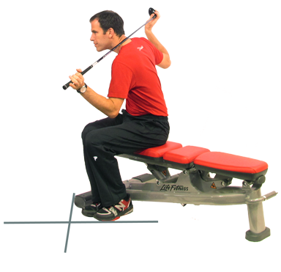

Trunk Has Flexed And Hands Have Grabbed The Club To Attempt To Gain More Range Of Motion

What To Look For In The Seated Trunk Rotation Test
Ask the client to rotate their thorax as far to the right as they can without moving the feet or knees. Compare the AC Joint shoulder to shoulder to the shaft on the ground. They should be able to rotate past the 45 degree mark. Typical measurements range from 45-70 degrees in both directions. Repeat on the opposite side.
Watch the client’s knees and hips. It is imperative that the knees and pelvis stay still and point forward during the test.

Physical Causes For Limitations In The Seated Trunk Rotation Test
When a client presents with a limitation in thorax rotation the following may be significant factors:
Thoracic spine mobility
- Any restriction in thoracic spinal mobility is going to make this test difficult to perform. Degenerative joint disease, facet subluxations or rib cage restrictions are the usual suspects! If the thoracic spine has too much kyphosis (“C” Posture), the client's mobility will be greatly reduced since the spine is poor at flexion combined with rotation.
Muscular and myofascial restrictions in the thorax and spinal muscles
- Any tightness or fascial restrictions of the latissimus dorsi, erector spinae, multifidus, deep spinal rotators, quadratus lumborum, etc., will reduce the player’s ability to disassociate the lower body from the upper body.
Cervical spine mobility
- Any restriction in rotation in the cervical spine can limit the player’s ability to rotate the thorax. The cervical spine goes through 70 degrees of rotation in the average player.

Seated Trunk Rotation Test Pitfalls
When taking a client through this exam be aware of the following:
- Monitor the knees and feet during the test because the client will tend to shift the knees apart while attempting to rotate the thorax. Lay a shaft across their thighs to help monitor.
- It is OK for the client to rotate the head and neck along with the thorax since we are only testing thoracic spine mobility - not the neck.
- Make sure the client is in a full and upright seated posture.
- Never rotate the thorax into a position of pain or discomfort.

SUMMARY OF SEATED TRUNK ROTATION RESULTS (AMATEURS)

Degrees-Right Total Responses: 1254
Answer | # Responses | Percentage
Less than 11 degrees | 37 | 3.0%
11-20 degrees | 2 | 0.2%
21-30 degrees | 22 | 1.8%
31-40 degrees | 67 | 5.3%
41-50 degrees | 207 | 16.5%
51-60 degrees | 310 | 24.7%
61-70 degrees | 314 | 25.0%
71-80 degrees | 200 | 15.9%
Greater than 80 degrees | 95 | 7.6%

Degrees-Left Total Responses: 1254
Answer | # Responses | Percentage
Less than 11 degrees | 37 | 3.0%
11-20 degrees | 6 | 0.5%
21-30 degrees | 20 | 1.6%
31-40 degrees | 75 | 6.0%
41-50 degrees | 232 | 18.5%
51-60 degrees | 302 | 24.1%
61-70 degrees | 310 | 24.7%
71-80 degrees | 190 | 15.2%
Greater than 80 degrees | 82 | 6.5%

SUMMARY OF SEATED TRUNK ROTATION RESULTS (PGA TOUR)

Degrees-Right Total Responses: 31
Answer | # Responses | Percentage
Less than 41 degrees | 0 | 0%
41-50 degrees | 3 | 9.7%
51-60 degrees | 11 | 35.5%
61-70 degrees | 9 | 29.0%
71-80 degrees | 6 | 19.4%
Greater than 80 degrees | 2 | 6.5%

Degrees-Left Total Responses: 31
Answer | # Responses | Percentage
Less than 41 degrees | 0 | 0%
41-50 degrees | 5 | 16.1%
51-60 degrees | 10 | 32.3%
61-70 degrees | 8 | 25.8%
71-80 degrees | 6 | 19.4%
Greater than 80 degrees | 2 | 6.5%

